**ImageNet**

1. Download

http://www.image-net.org/challenges/LSVRC/2012/nnoupb/ILSVRC2012_img_test.tar

http://www.image-net.org/challenges/LSVRC/2012/nnoupb/ILSVRC2012_img_val.tar

http://www.image-net.org/challenges/LSVRC/2012/nnoupb/ILSVRC2012_img_train.tar

http://www.image-net.org/challenges/LSVRC/2012/nnoupb/ILSVRC2012_devkit_t12.tar

http://www.image-net.org/challenges/LSVRC/2012/nnoupb/ILSVRC2012_bbox_train_v2.tar

1. Extract ILSVRC2012_img_train.tar and ILSVRC2012_img_val.tar to ./train and ./validation folder. Run trainprep.sh and valprep.sh after extraction at each folder.

**VOC**

1. Download

http://host.robots.ox.ac.uk/pascal/VOC/voc2007/VOCtrainval_06-Nov-2007.tar

http://host.robots.ox.ac.uk/pascal/VOC/voc2007/VOCtest_06-Nov-2007.tar

http://host.robots.ox.ac.uk/pascal/VOC/voc2007/VOCdevkit_08-Jun-2007.tar

1. Extract all tar file to the same folder VOCdevkit

**Coco**

1. Download dataset and follow http://cocodataset.org/#download
2. Download COCOAPI from https://github.com/cocodataset/cocoapi
3. Download MS Build Tool from https://visualstudio.microsoft.com/downloads/#build-tools-for-visual-studio-2017
4. Install MSBuild Tool with Visual C++ Tool

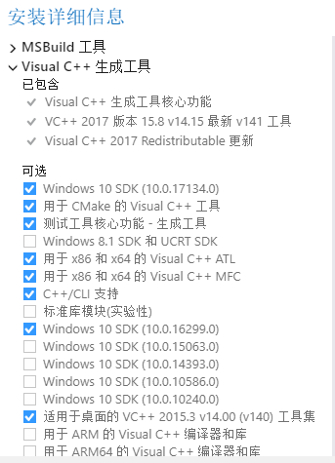

1. Update setuptools

pip install --upgrade setuptools

1. Run command in Makefile

python setup.py build_ext install

rm -rf build

if status 2 error occurs

change extra_compile_args=['-Wno-cpp', '-Wno-unused-function', '-std=c99']

to extra_compile_args={'gcc': ['/Qstd=c99']} in setup.py

1. Verify installation with demo jupyter notebook. Be aware to move the notebook to another folder since there is a conflict with pycocotools folder. Cite from https://github.com/philferriere/cocoapi

**Use**

**pip install pycocotools**

https://github.com/philferriere/cocoapi